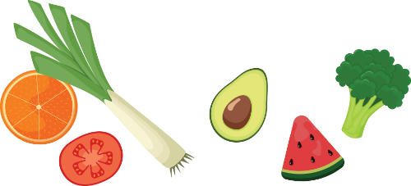
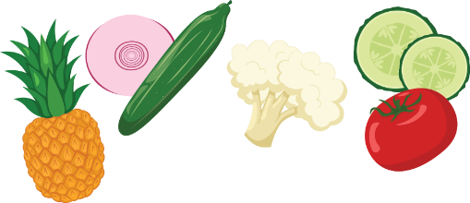
Others
Vegetables
Meat
Baking
Produce
Bakery
Week of ___________
Grocery List

