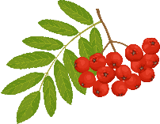

Grocery List
Frozen
Drinks
Vegetables
Baking
Bakery
Produce
Others
Meat

