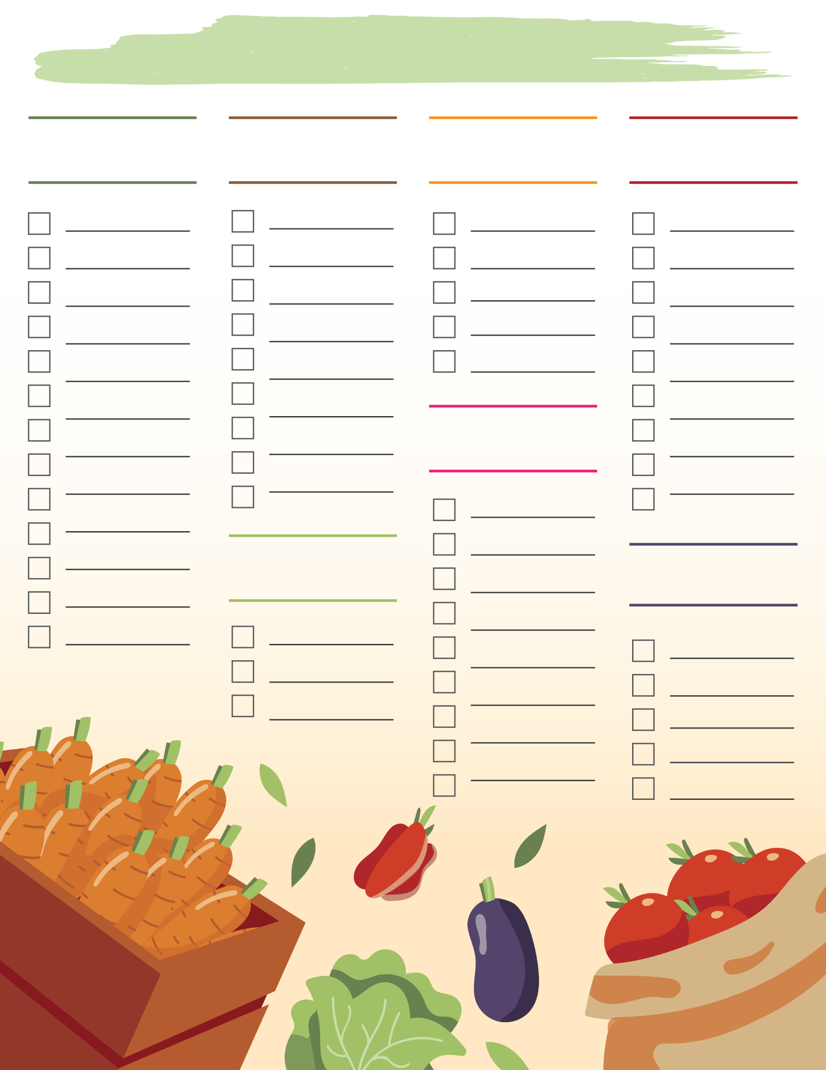
Grocery List
Pastas
Frozen
Vegetables
Drinks
Meat
Bakery
Produce

