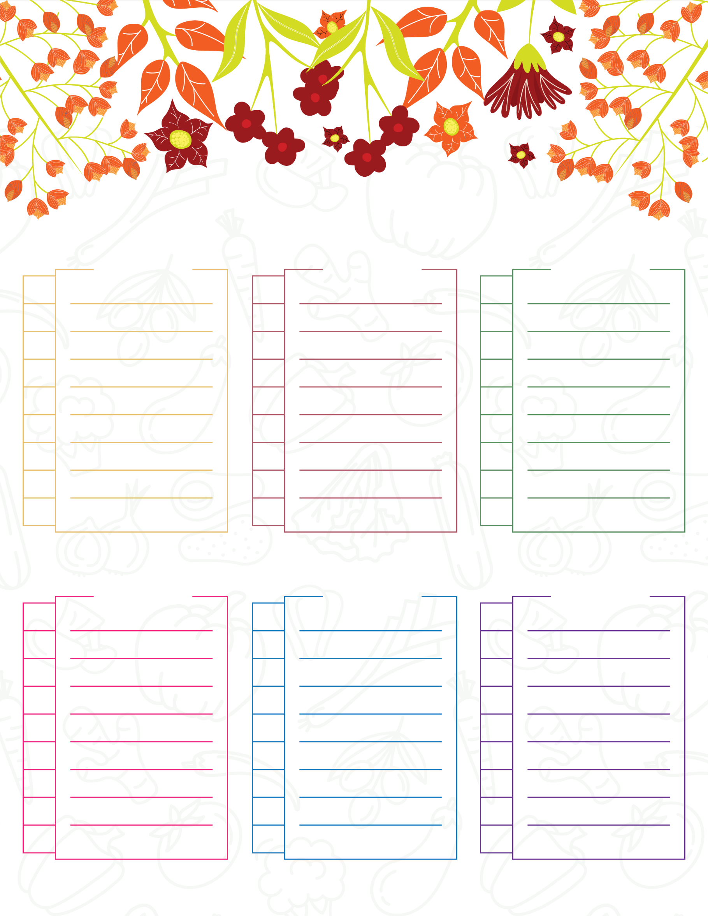
Pastas
Drinks
Others
Fish
Produce
Baking
Grocery List

