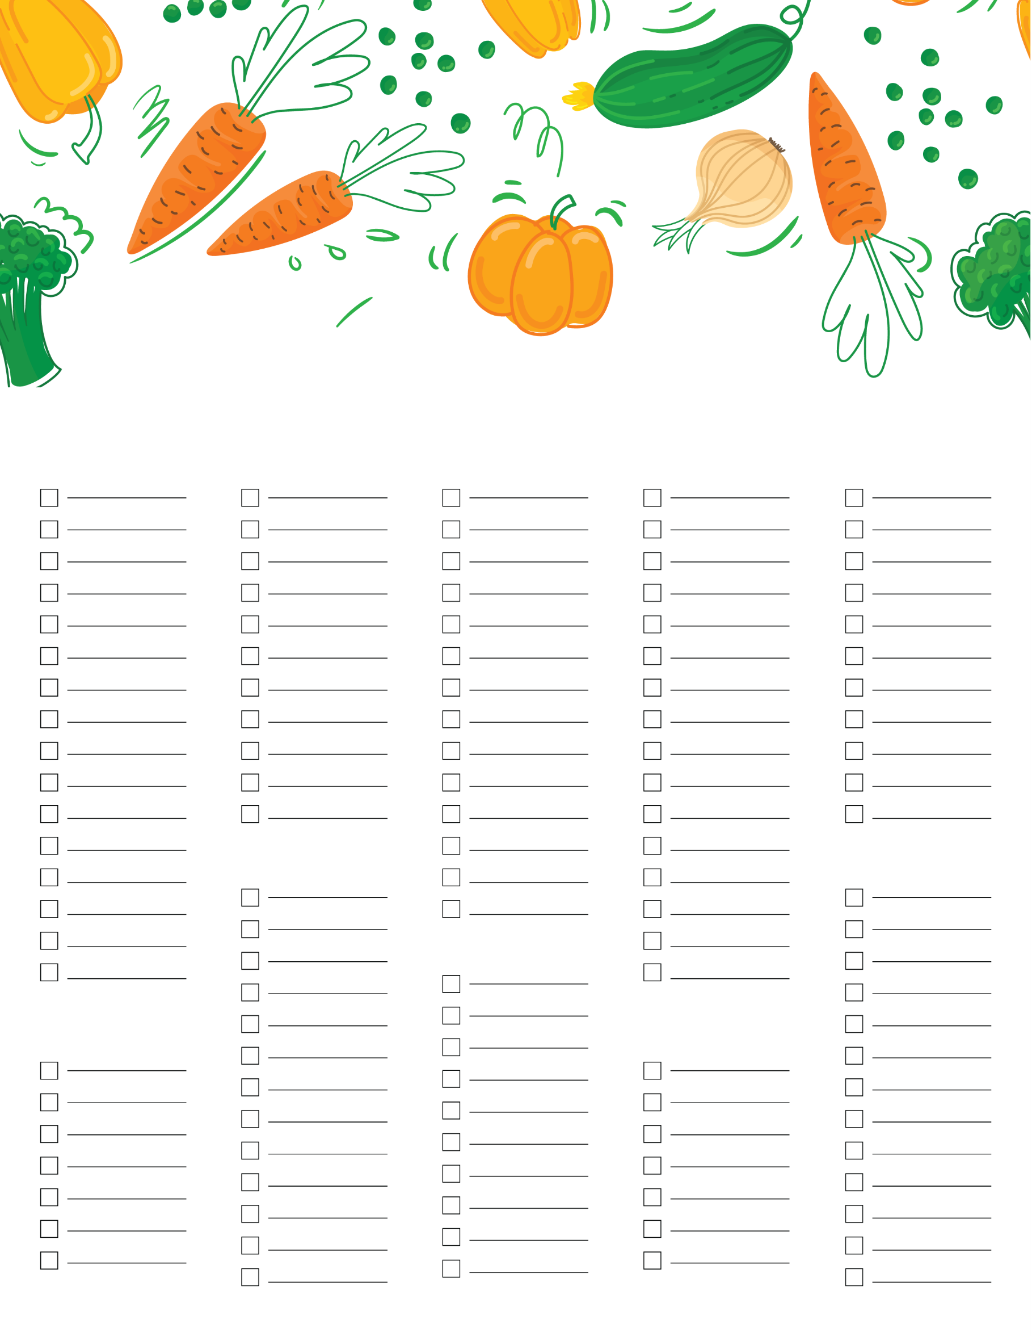
Date ______
Grocery List
Vegetables
Drinks
Meat
Bakery
Produce
Snacks
Grains
Others
Frozen
Baking

