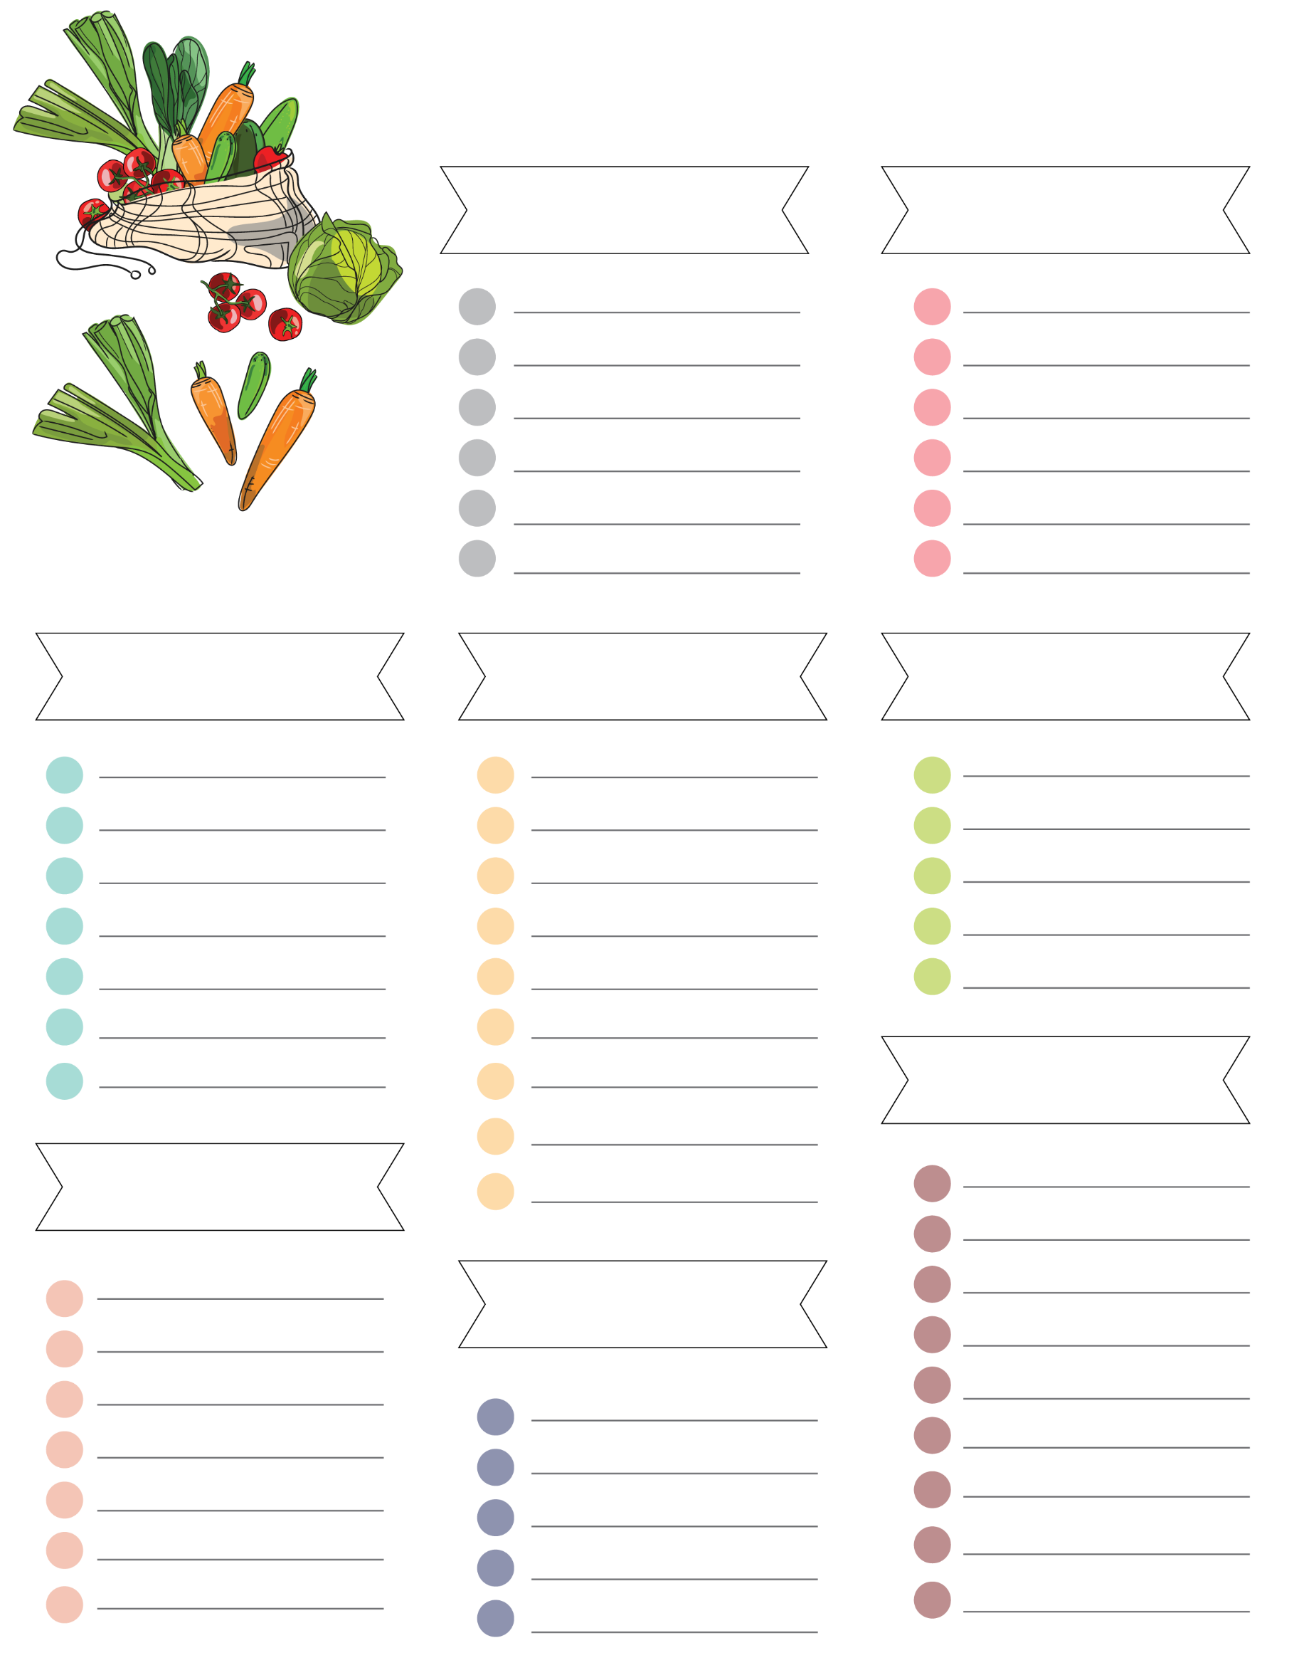
Grocery List
Baking
Drinks
Others
Produce
Vegetables
Bakery
Frozen
Meat

