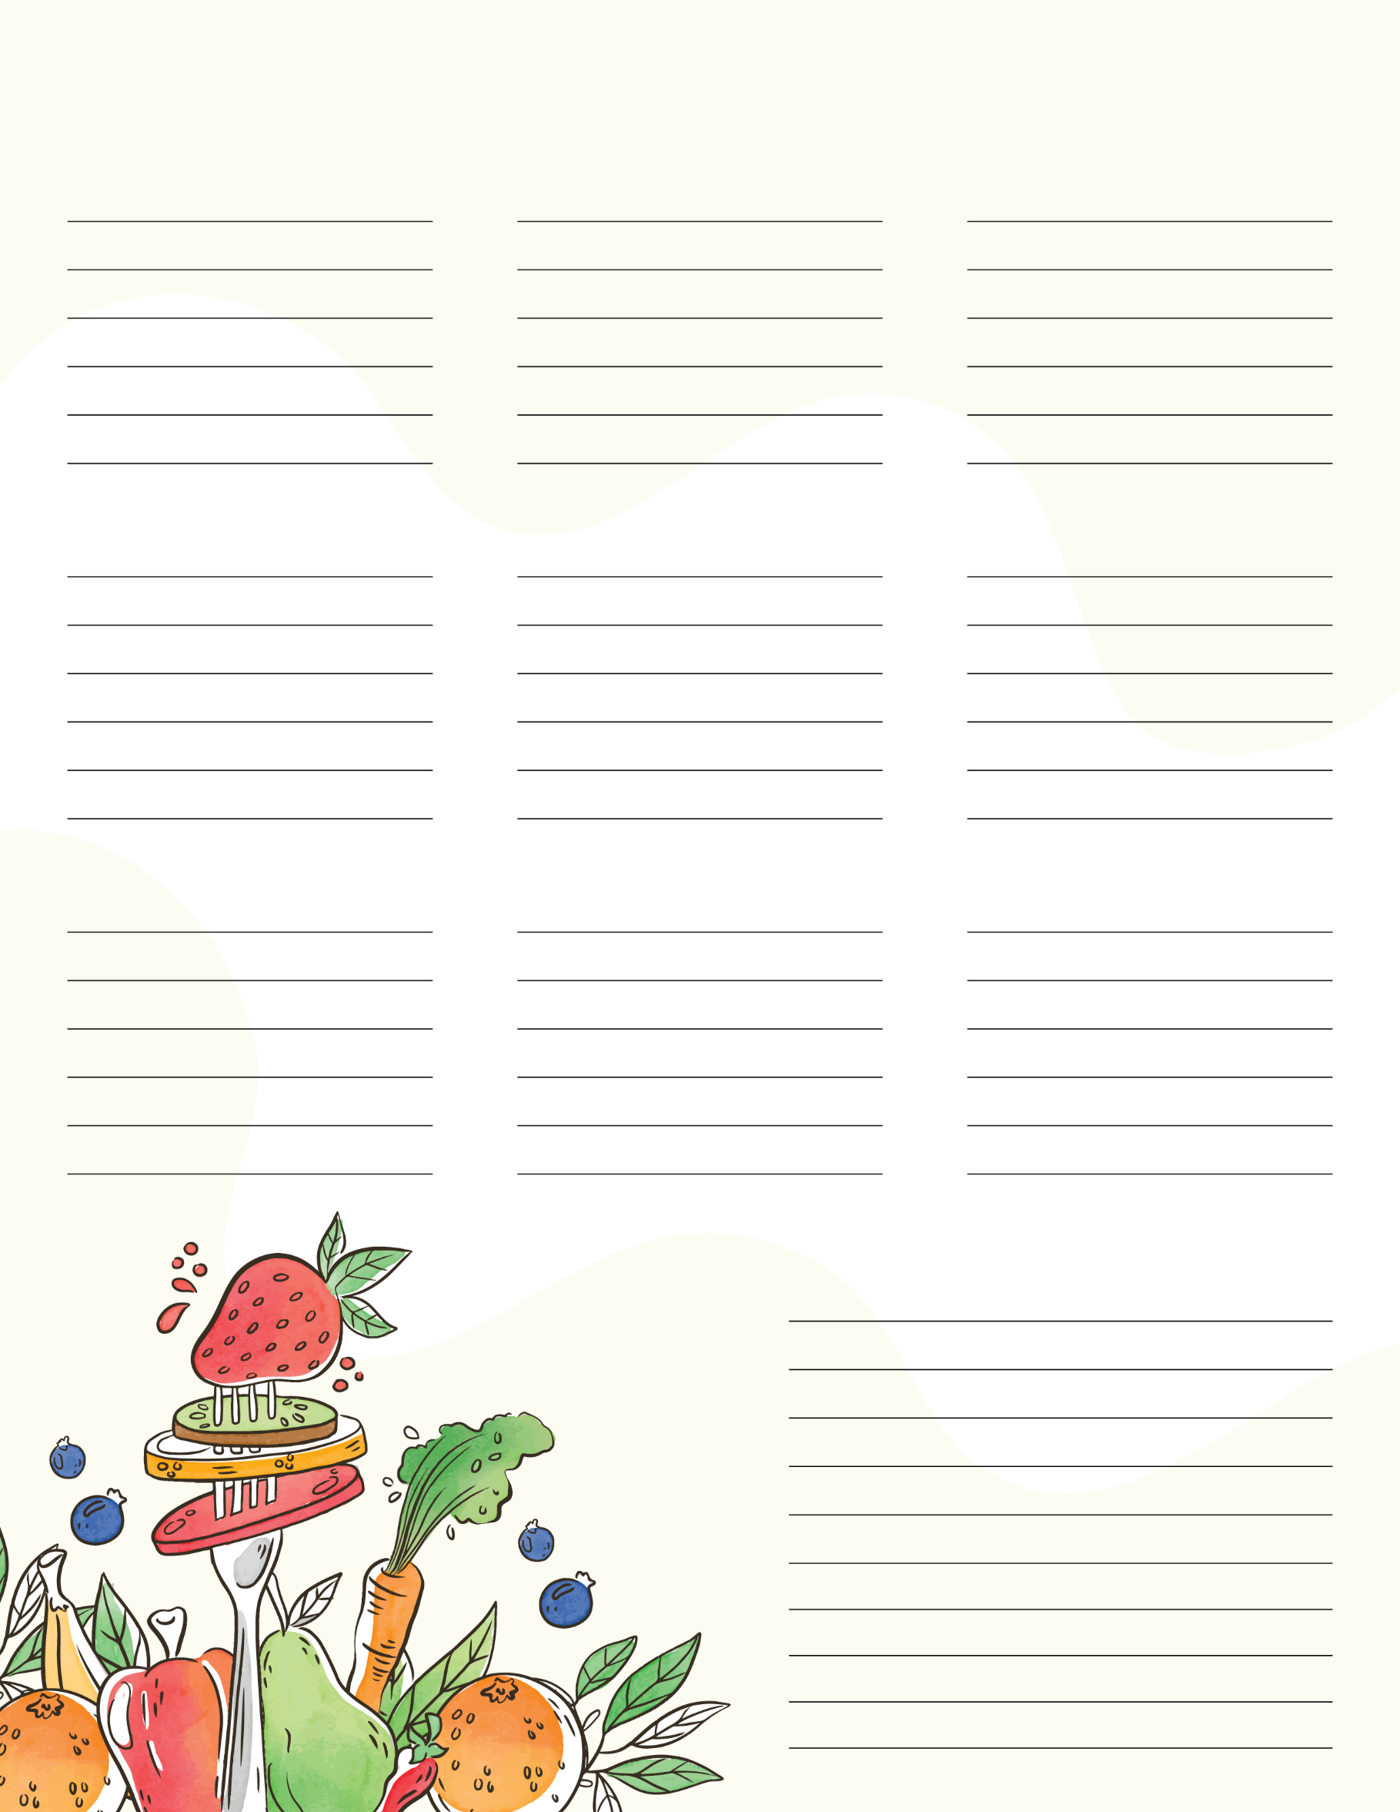
Pastas
Fish
Milk
Others
Drinks
Vegetables
Meat
Produce
Baking
Bakery
Grocery List
Frozen

